**ASSIGNMENT**

**(JAVASCRIPT BASIC AND DOM)**

# Q.1 What is JavaScript. How to use it?

Ans: JavaScript is a scripting or programming language that allows you to implement complex features on web pages like displaying timely content updates, interactive maps, animated 2D/3D graphics, scrolling video jukeboxes, etc. It is a lightweight, cross-platform, single-threaded, and interpreted compiled programming language. It is used in script tag by including its basic syntax and functions as required.

# Q.2 How many types of Variables in JavaScript?

Ans: There are three types of variables in JavaScript let (letter) var (variable) and const (constant).

# Q.3 Define a Data Types in js?

Ans: Data types describe the different types or kinds of data that we're going to be work with and store in variables. JavaScript includes primitive and non-primitive data types. The primitive data types in JavaScript include string, number, Boolean, undefined, null, and symbol. The non-primitive data type includes the object. A variable of primitive data type can contain only a single value.

* **String :-** A string data type is a group of characters or textual content enclosed by single quotes (‘ ‘) or double-quotes (” “), or tick signs (` `).
* **Number :- A number data type is a numeric value. It can be an integer (positive or negative), floating-point, or exponential.**
* **Boolean :- Boolean is a logical data type used to compare two variables or check a condition. It has only two values, namely, true and false.**
* **Undefined :- An undefined data type means that a variable is declared and not assigned any value. It is the default value of a variable that has not been defined.**
* **Null :- A null value means no value. It means an empty value or absence of value.**
* **Symbol :- The symbol data type in JavaScript defines a property of an object which is private to the object. The value with the Symbol data type can be referred to as a symbol value. The symbol refers to the ‘key’ of the key-value pair of an object. Every symbol is unique. Two symbols with the same key values are not the same.**
* **Object :- An object data type stores multiple values or data collection regarding properties and methods. It contains key-value pairs in its address. The properties of the object are written as key: value pairs. Each pair is separated by commas, enclosed in curly braces {}. The key must be a string, and the value can be of any data type.**

# Q.4 Write a mul Function Which will Work Properly When invoked With Following Syntax.

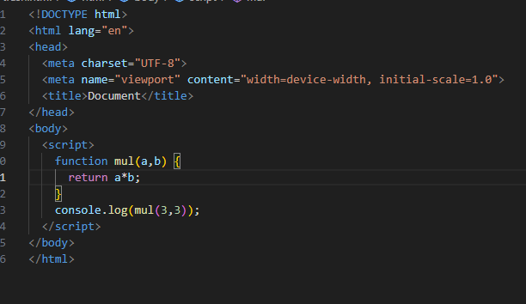

# Q.5 What the difference between undefined and undeclared in JavaScript?

Ans: Undefined means a variable is declared but it has no value assigned while undeclared means when we try to access any variable which is not initialised or declared earlier using var const or let keyword.

# Q.7 Check if typeof '10' is exactly equal to 10. If not make it exactly equal?

Ans: No typeof ‘10’ is not exactly equal to 10.

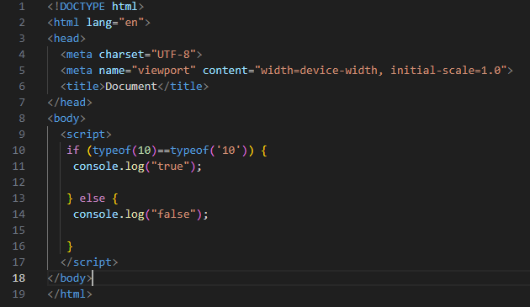

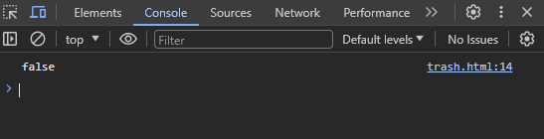

To make it equal we have to remove string and replace it with number datatype.

# Q.10 What is Condition Statement?

Ans: Conditional statements help to perform different actions for different decisions.

In JavaScript we have the following conditional statements:

* Use if to specify a block of code to be executed, if a specified condition is true
* Use else to specify a block of code to be executed, if the same condition is false
* Use else if to specify a new condition to test, if the first condition is false
* Use switch to specify many alternative blocks of code to be executed.

# Q.18 What is a Loop and Switch Case in JavaScript define that ?

Ans:

* A loop is a programming tool that is used to repeat a set of instructions. A loop will continue to iterate until a specified condition, commonly known as a stopping condition, is met.
* JavaScript switch statement provides a way to execute different code blocks based on different conditions. It’s an alternative to using multiple if...else if...else statements when you have multiple conditions to check.

# Q.19 What is the use of is Nan function?

Ans: In JavaScript NaN is short for "Not-a-Number". The isNaN() method is used to return true if a value is NaN. The isNaN() method converts the value to a number before testing it.

# Q.20 What is the difference between && and || in JavaScript?

Ans: In JavaScript &&(AND) operator gives true output if all the conditions are true while ||(OR) operator gives true output if any one of the given conditions are true.

# Q.21 What is the use of Void (0)?

Ans: The void operator evaluates an expression and returns undefined . By running void(0) in the URL JavaScript code, nothing is evaluated or returned.